

* **Login:**

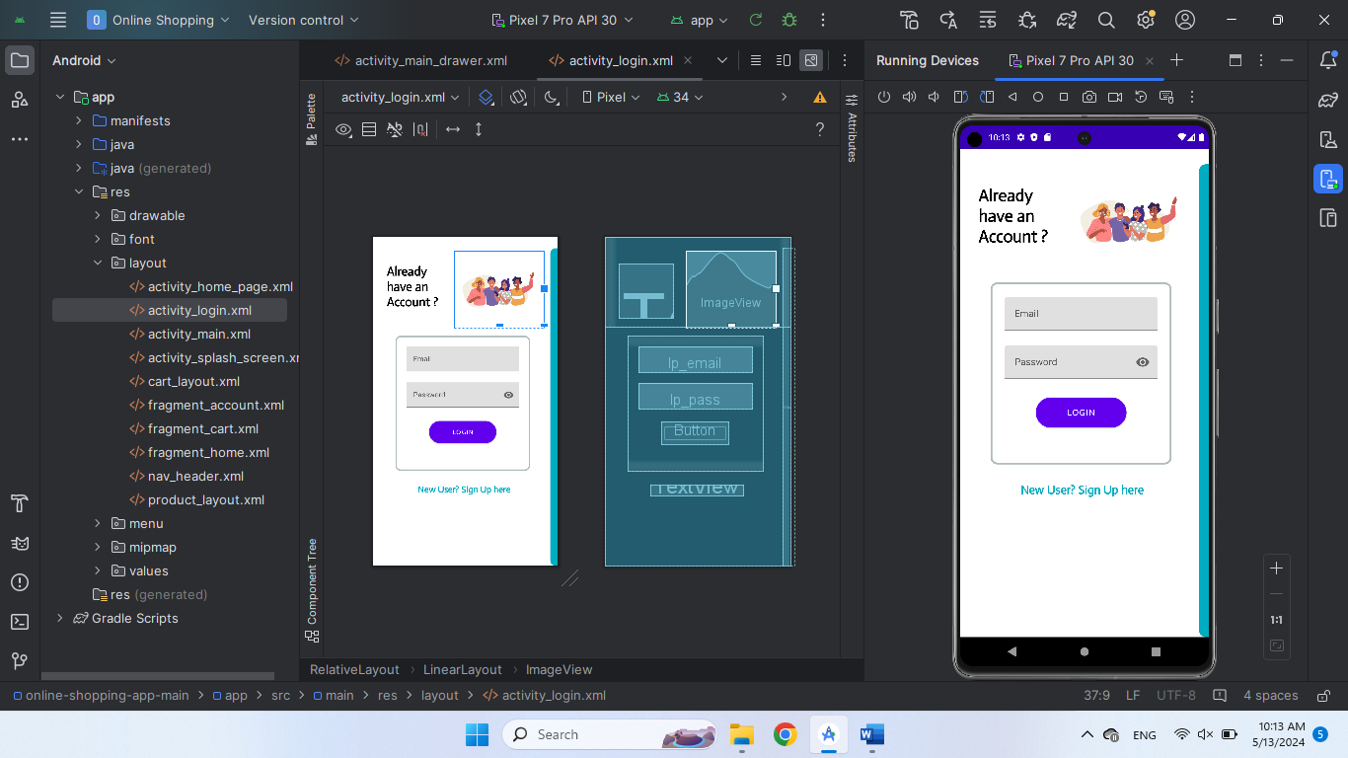

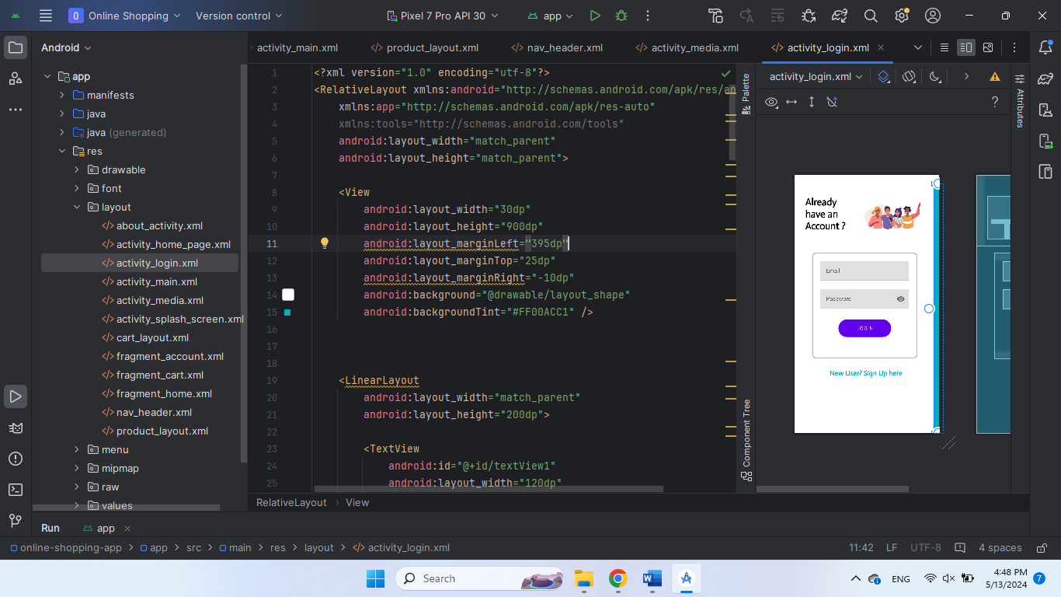

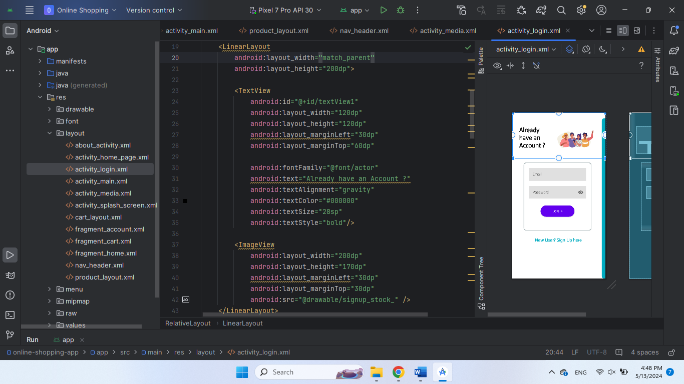

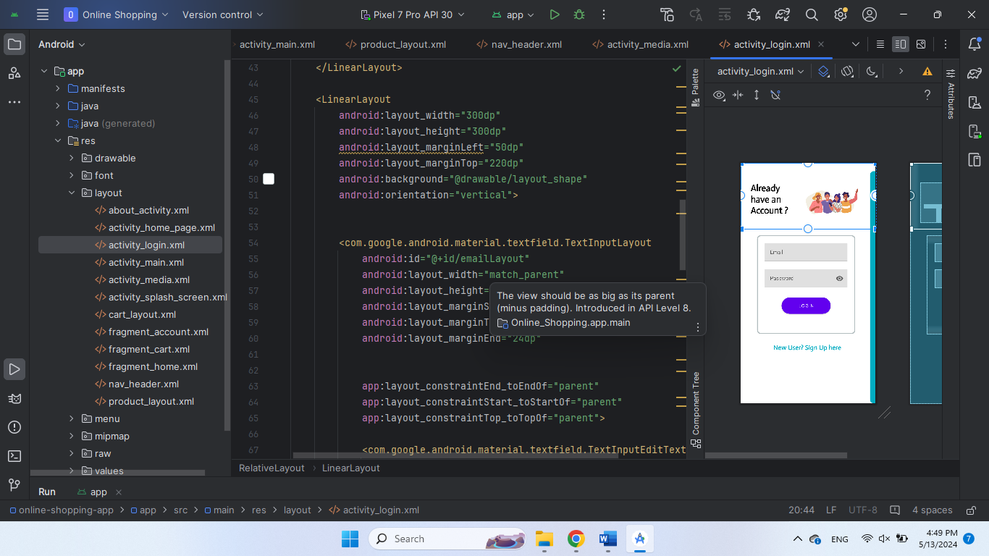

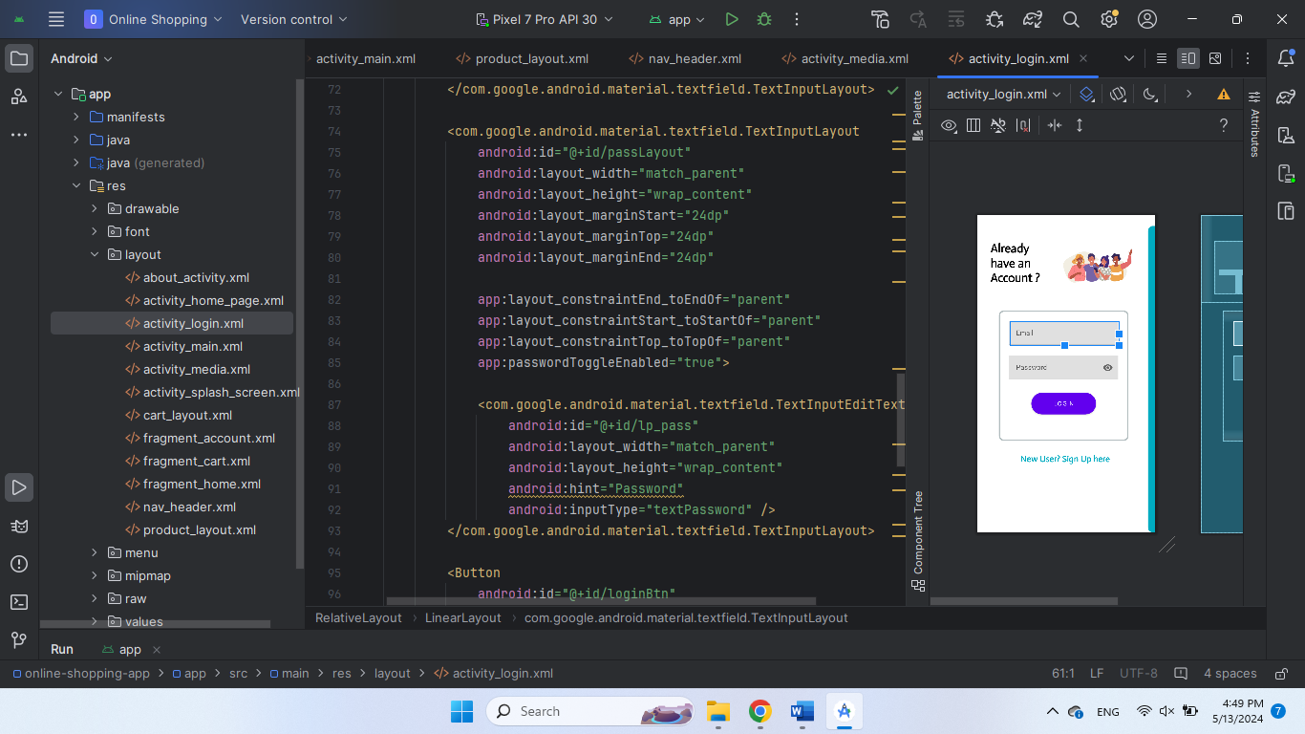

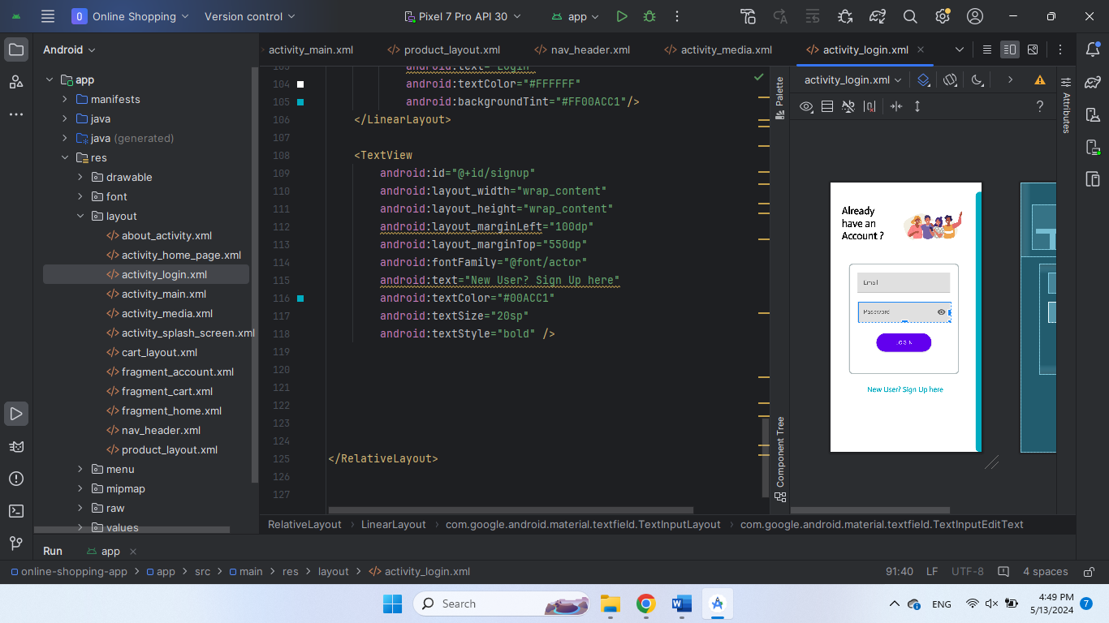

**Register:**

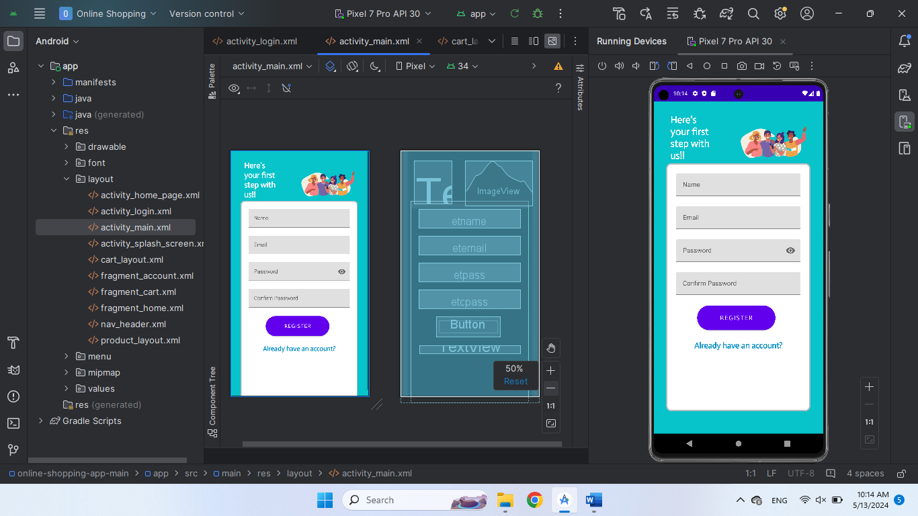

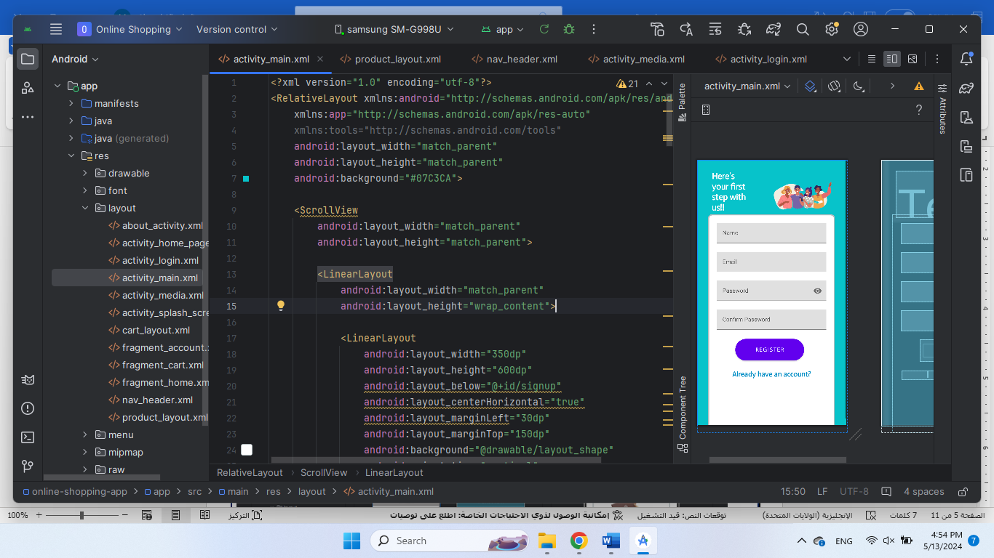

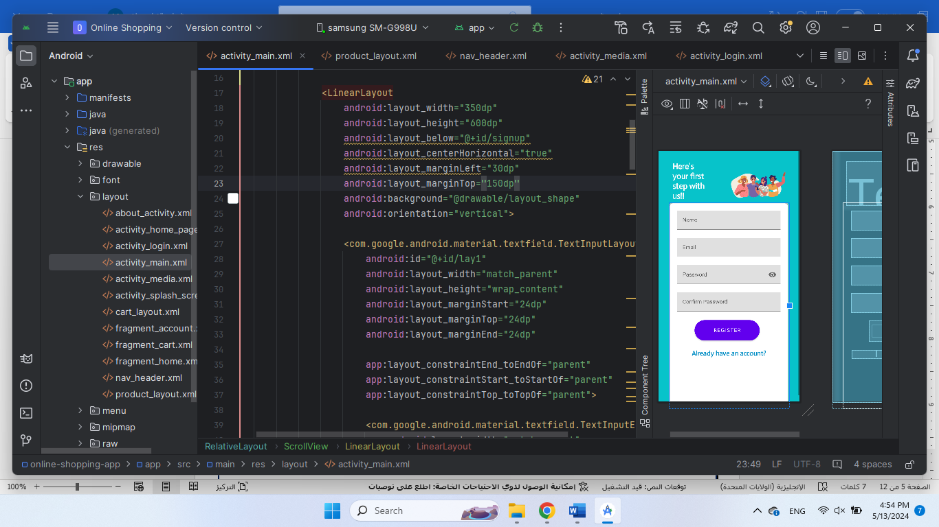

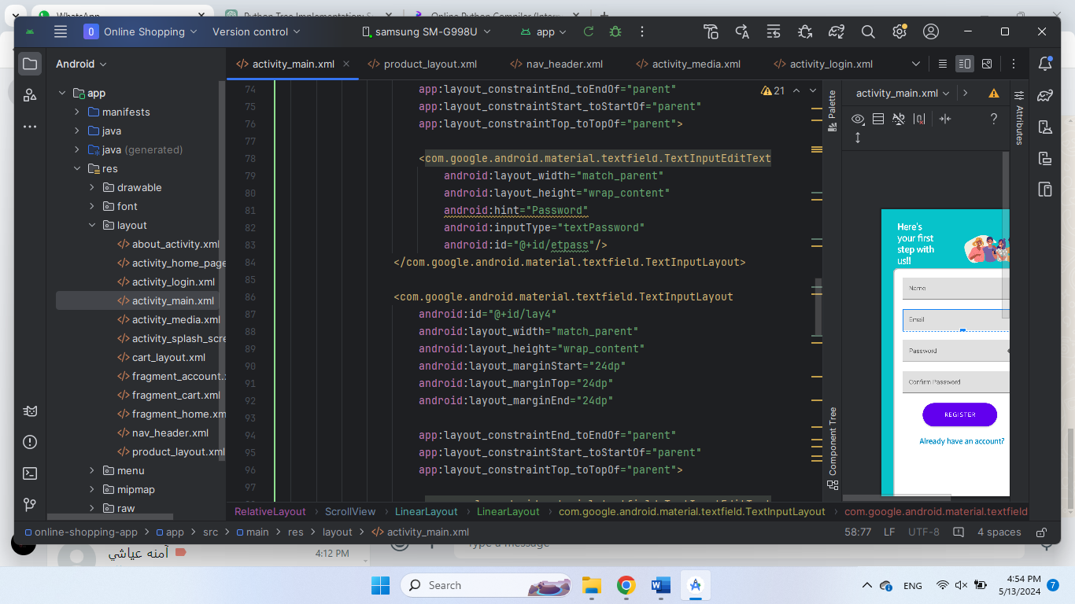

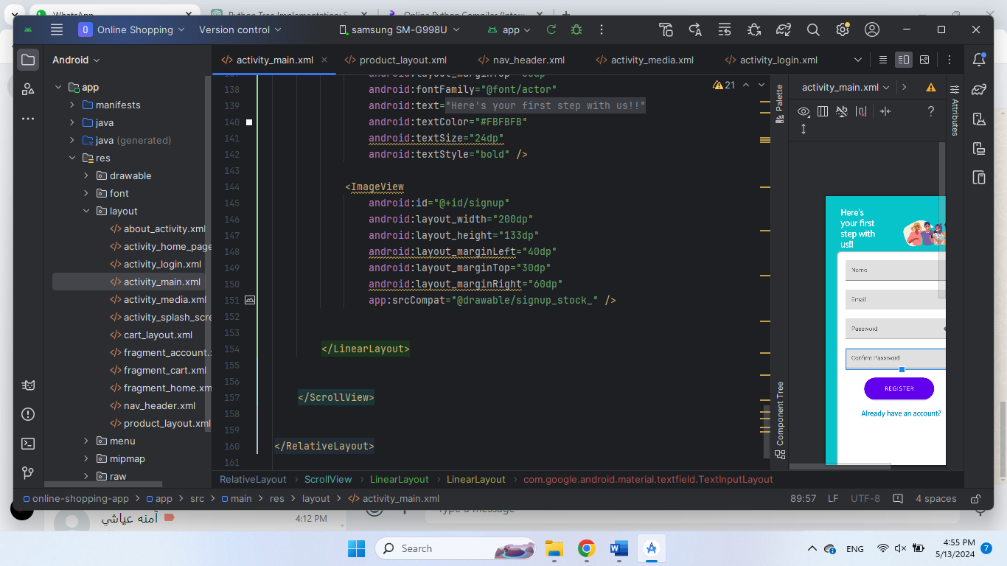

**Home:**

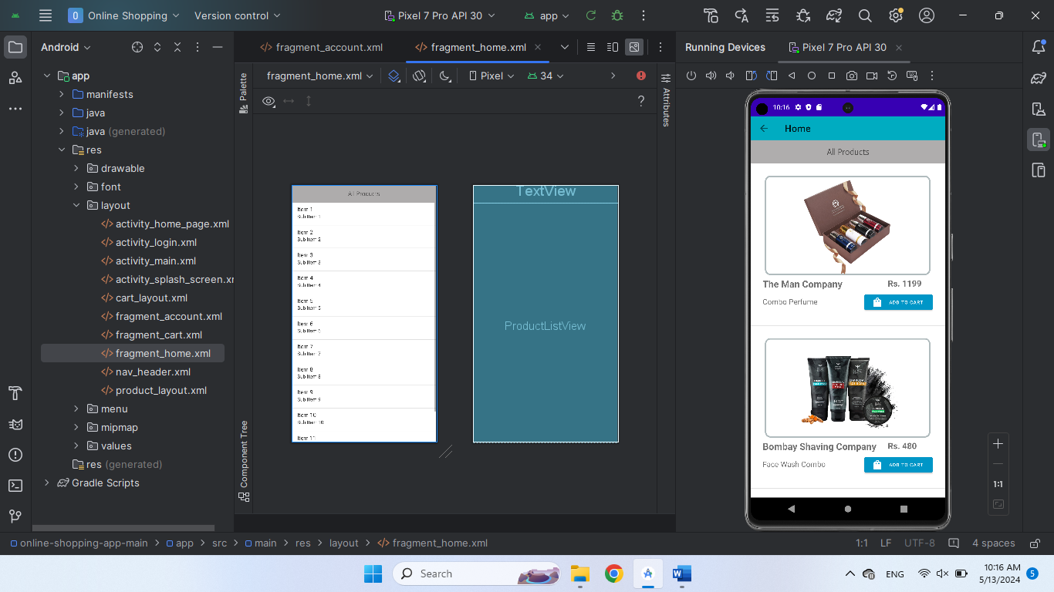

<?xml version="1.0" encoding="utf-8"?>  
<FrameLayout xmlns:android="http://schemas.android.com/apk/res/android"  
 xmlns:tools="http://schemas.android.com/tools"  
 android:layout_width="match_parent"  
 android:layout_height="match_parent"  
 tools:context=".home_fragment">  
  
 <TextView  
 android:layout_width="match_parent"  
 android:layout_height="50dp"  
 android:background="#E6A6A4A4"  
 android:text="All Products"  
 android:fontFamily="@font/actor"  
 android:gravity="center"  
 android:textSize="18sp"  
 />  
  
  
 <ListView  
 android:layout_width="wrap_content"  
 android:layout_height="wrap_content"  
 android:layout_marginTop="50dp"  
 android:id="@+id/ProductListView"  
 android:footerDividersEnabled="false"  
 android:headerDividersEnabled="false"  
 />  
</FrameLayout>

**product_layout**

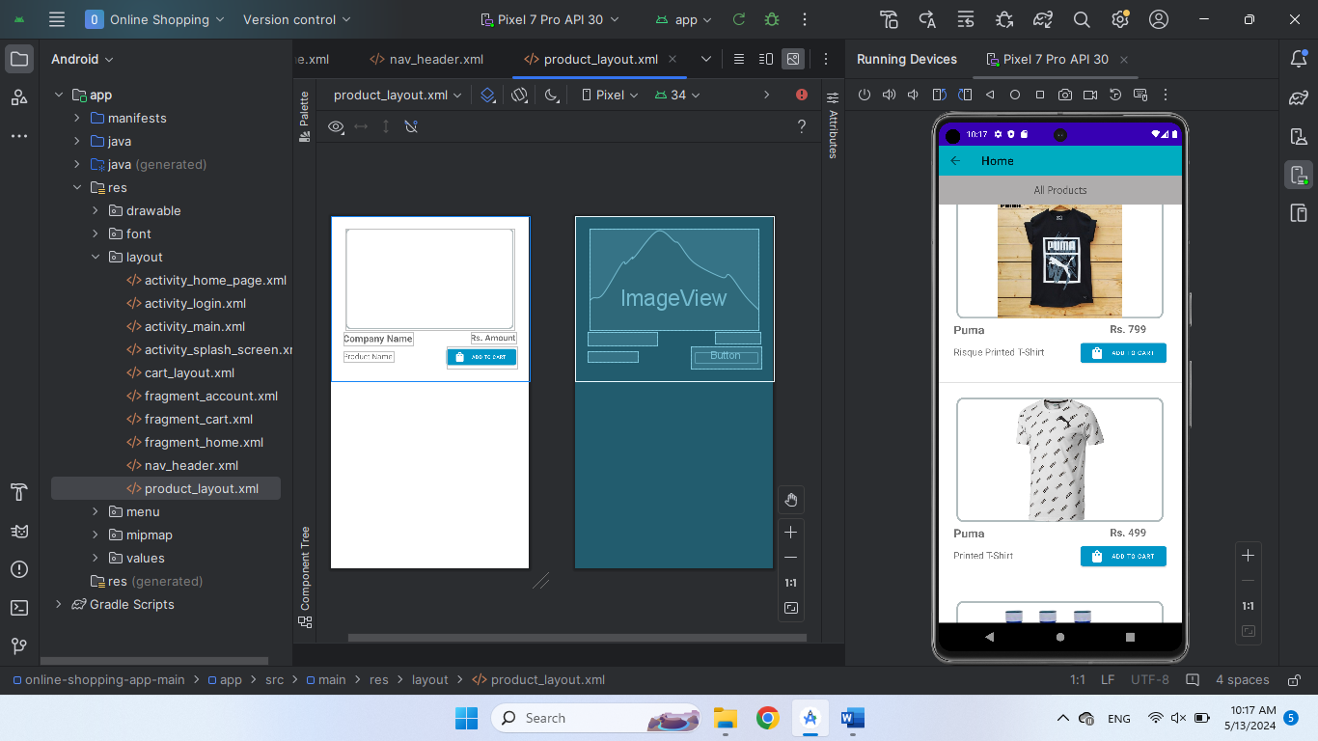

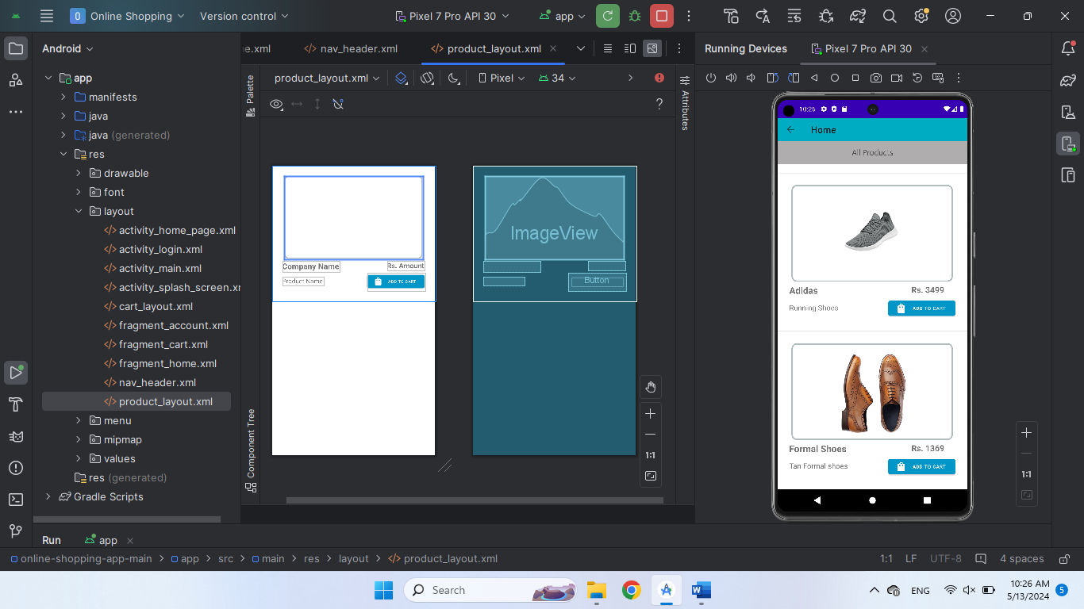

<?xml version="1.0" encoding="utf-8"?>  
<RelativeLayout xmlns:android="http://schemas.android.com/apk/res/android"  
 android:layout_width="match_parent"  
 android:layout_height="wrap_content"  
 xmlns:app="http://schemas.android.com/apk/res-auto"  
 android:orientation="vertical">  
  
 <ImageView  
 android:id="@+id/proImage"  
 android:layout_width="350dp"  
 android:layout_height="210dp"  
 android:layout_marginLeft="30dp"  
 android:layout_marginTop="25dp"  
 android:background="@drawable/layout_shape" />  
  
 <TextView  
 android:id="@+id/compName"  
 android:layout_width="wrap_content"  
 android:layout_height="wrap_content"  
 android:layout_marginStart="25dp"  
 android:layout_marginLeft="25dp"  
 android:layout_marginTop="240dp"  
 android:layout_marginEnd="75dp"  
 android:layout_marginBottom="75dp"  
 android:text="Company Name"  
 android:textSize="20sp"  
 android:textStyle="bold" />  
  
 <TextView  
 android:id="@+id/proName"  
 android:layout_width="wrap_content"  
 android:layout_height="wrap_content"  
 android:layout_marginLeft="25dp"  
 android:layout_marginTop="280dp"  
 android:text="Product Name"  
 android:textSize="16sp" />  
  
 <TextView  
 android:id="@+id/amtView"  
 android:layout_width="wrap_content"  
 android:layout_height="wrap_content"  
 android:layout_marginLeft="290dp"  
 android:layout_marginTop="240dp"  
 android:text="Rs. Amount"  
 android:textSize="18sp"  
 android:textStyle="bold" />  
  
 <Button  
 android:id="@+id/cartImg"  
  
 android:layout_width="145dp"  
 android:layout_height="45dp"  
 android:layout_marginStart="240dp"  
 android:layout_marginTop="270dp"  
 android:backgroundTint="@color/accInfoColor"  
 android:text="Add to cart"  
 android:textSize="10sp"  
 app:icon="@drawable/ic_baseline_shopping_bag_24" />  
  
</RelativeLayout>

**Cart page**

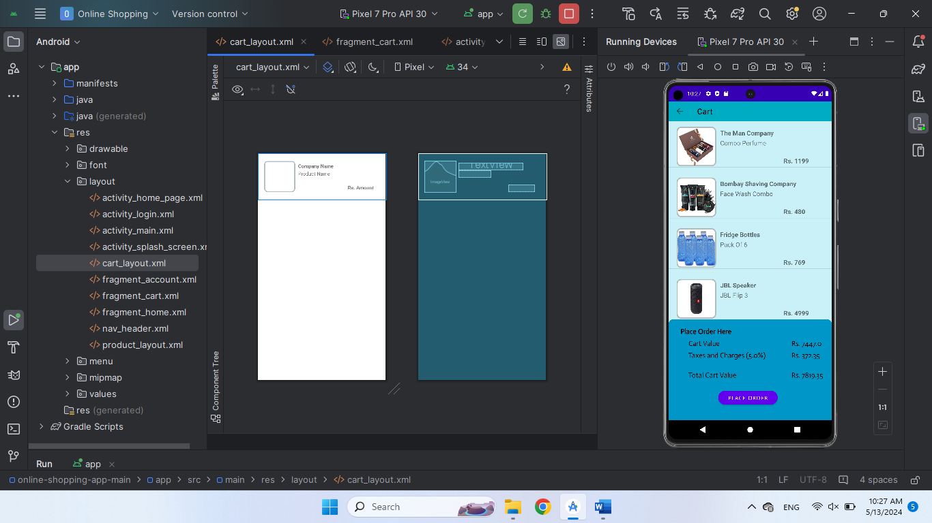

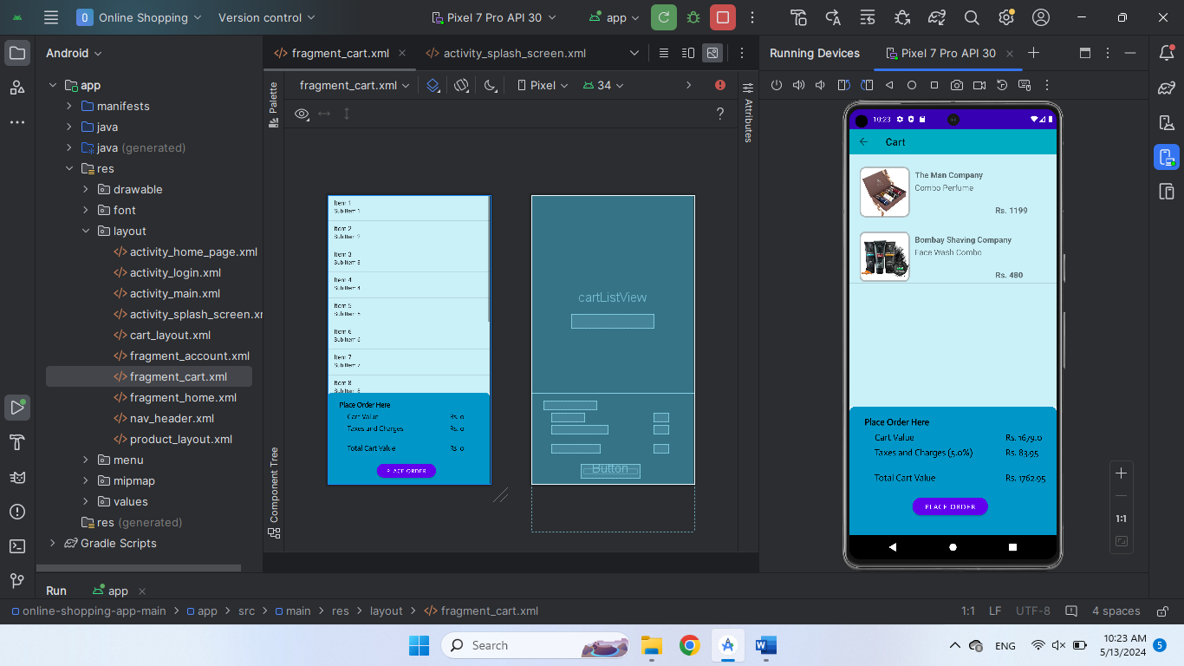

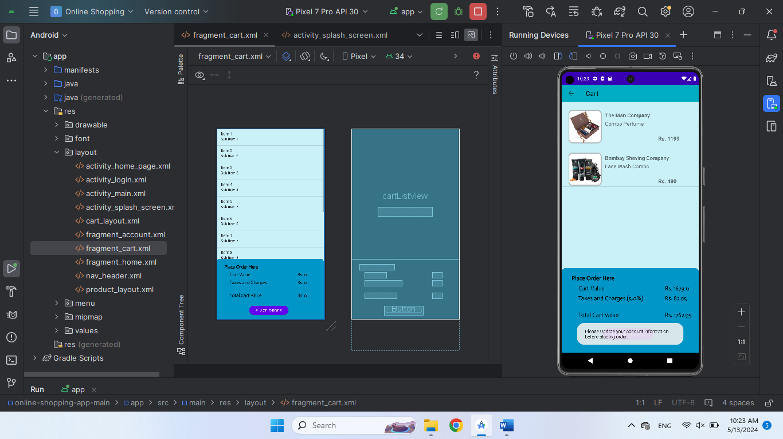

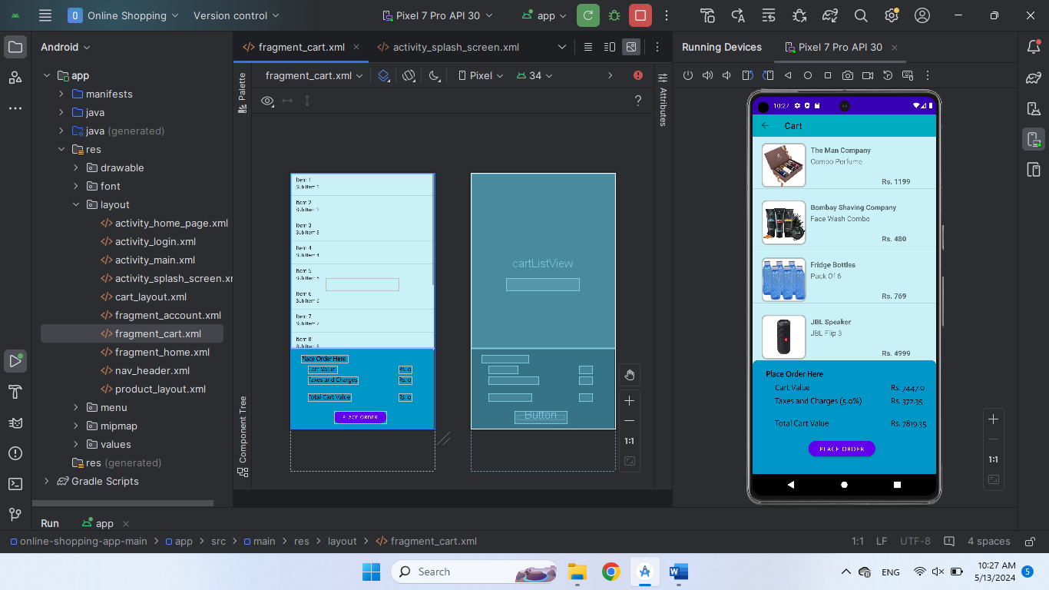

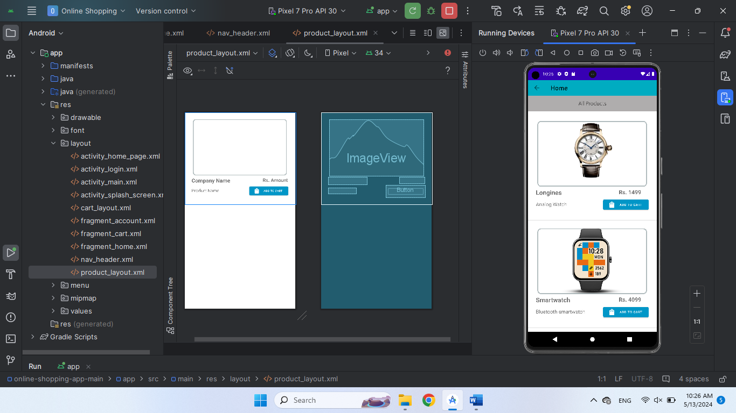

<?xml version="1.0" encoding="utf-8"?>  
<FrameLayout xmlns:android="http://schemas.android.com/apk/res/android"  
 xmlns:tools="http://schemas.android.com/tools"  
 android:layout_width="match_parent"  
 android:layout_height="match_parent"  
 tools:context=".cart_fragment">  
  
 <ListView  
 android:layout_width="wrap_content"  
 android:layout_height="500dp"  
 android:id="@+id/cartListView"  
 android:footerDividersEnabled="true"  
 android:headerDividersEnabled="false"  
 android:background="@color/accInfo"  
 />  
 <TextView  
 android:layout_width="wrap_content"  
 android:layout_height="wrap_content"  
 android:id="@+id/emptyCart"  
 android:text="Your cart is empty"  
 android:layout_marginLeft="100dp"  
 android:layout_marginTop="300dp"  
 android:textSize="26sp"  
 android:visibility="invisible"  
 />  
 <RelativeLayout  
 android:layout_width="match_parent"  
 android:layout_height="350dp"  
 android:layout_marginTop="500dp"  
 android:background="@drawable/layout_shape"  
 android:backgroundTint="@color/accInfoColor">  
  
 <TextView  
 android:layout_width="wrap_content"  
 android:layout_height="wrap_content"  
 android:layout_marginLeft="30dp"  
 android:layout_marginTop="20dp"  
 android:fontFamily="@font/actor"  
 android:text="Place Order Here "  
 android:textColor="@color/black"  
 android:textSize="18sp"  
 android:textStyle="bold" />  
  
 <TextView  
 android:layout_width="wrap_content"  
 android:layout_height="wrap_content"  
 android:layout_marginLeft="50dp"  
 android:layout_marginTop="50dp"  
 android:text="Cart Value "  
 android:textStyle=""  
 android:fontFamily="@font/actor"  
 android:textSize="18sp"  
 android:textColor="@color/black"  
 />  
  
 <TextView  
 android:id="@+id/cartVal"  
 android:layout_width="wrap_content"  
 android:layout_height="wrap_content"  
 android:layout_marginLeft="310dp"  
 android:layout_marginTop="50dp"  
 android:fontFamily="@font/actor"  
 android:text="Rs. 0"  
 android:textColor="@color/black"  
 android:textSize="18sp"  
 android:textStyle="" />  
  
 <TextView  
 android:id="@+id/taxes"  
 android:layout_width="wrap_content"  
 android:layout_height="wrap_content"  
 android:layout_marginLeft="50dp"  
 android:layout_marginTop="80dp"  
 android:fontFamily="@font/actor"  
 android:text="Taxes and Charges"  
 android:textColor="@color/black"  
 android:textSize="18sp" />  
 <TextView  
 android:id="@+id/cartTV"  
 android:layout_width="wrap_content"  
 android:layout_height="wrap_content"  
 android:layout_marginLeft="310dp"  
 android:layout_marginTop="80dp"  
 android:text="Rs. 0"  
 android:fontFamily="@font/actor"  
 android:textSize="18sp"  
 android:textColor="@color/black"  
 />  
  
 <TextView  
  
 android:layout_width="wrap_content"  
 android:layout_height="wrap_content"  
 android:layout_marginLeft="50dp"  
 android:layout_marginTop="130dp"  
 android:fontFamily="@font/actor"  
 android:text="Total Cart Value"  
 android:textColor="@color/black"  
 android:textSize="18sp" />  
 <TextView  
 android:id="@+id/totCV"  
 android:layout_width="wrap_content"  
 android:layout_height="wrap_content"  
 android:layout_marginLeft="310dp"  
 android:layout_marginTop="130dp"  
 android:text="Rs. 0"  
 android:fontFamily="@font/actor"  
 android:textSize="18sp"  
 android:textColor="@color/black"  
 />  
  
 <Button  
 android:id="@+id/placeOrder"  
 android:layout_width="150dp"  
 android:layout_height="35dp"  
 android:layout_marginStart="125dp"  
 android:layout_marginTop="180dp"  
 android:background="@drawable/button_shape"  
 android:fontFamily="@font/actor"  
 android:text="Place Order" />  
  
 </RelativeLayout>  
</FrameLayout>

**activity_home_page**

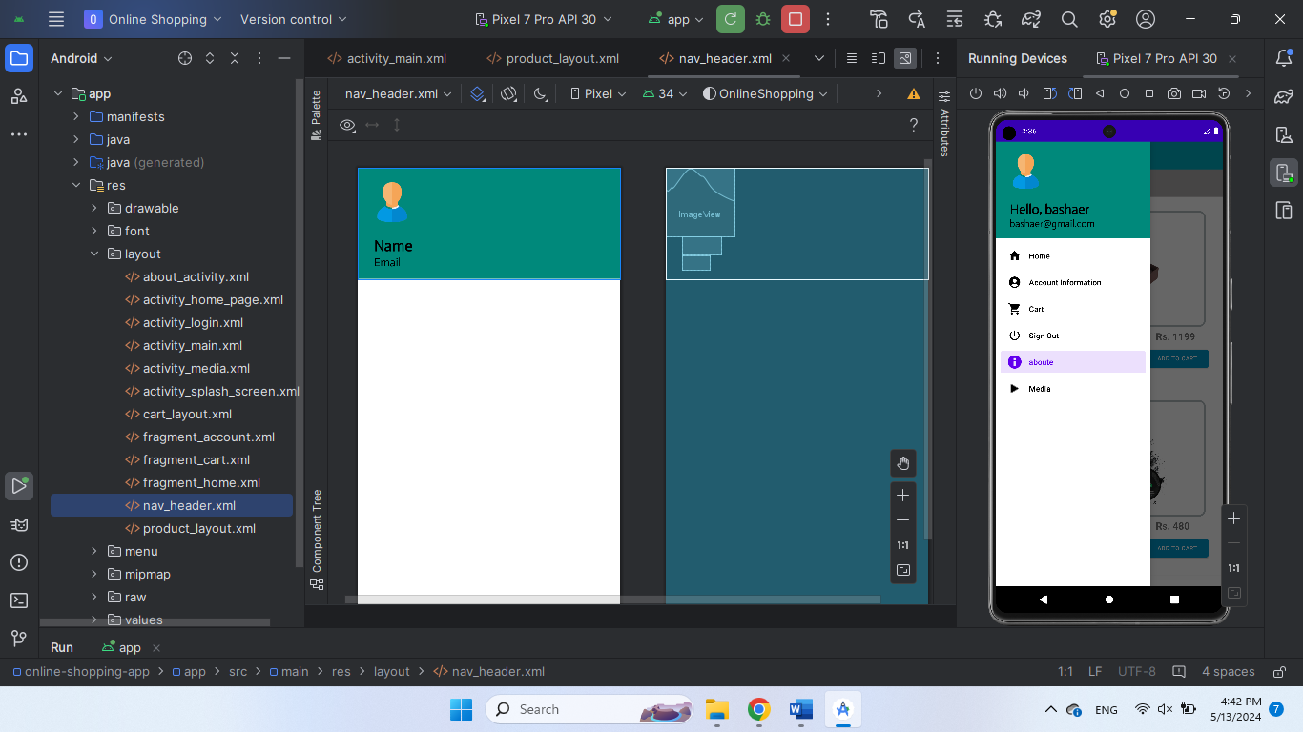

<?xml version="1.0" encoding="utf-8"?>  
<androidx.drawerlayout.widget.DrawerLayout  
 xmlns:android="http://schemas.android.com/apk/res/android"  
 xmlns:tools="http://schemas.android.com/tools"  
 xmlns:app="http://schemas.android.com/apk/res-auto"  
 android:layout_width="match_parent"  
 android:layout_height="match_parent"  
 android:id="@+id/drawerLayout"  
 tools:openDrawer="start"  
 tools:context=".HomePage">  
  
 <RelativeLayout  
 android:layout_width="wrap_content"  
 android:layout_height="wrap_content">  
  
 <androidx.appcompat.widget.Toolbar  
 android:id="@+id/toolbar"  
 android:layout_width="match_parent"  
 android:layout_height="50dp"  
 android:background="@color/themeColor"  
 android:textAlignment="center"  
 android:titleTextColor="@color/cardview_light_background"  
 app:title="Home">  
  
  
 </androidx.appcompat.widget.Toolbar>  
  
 <androidx.fragment.app.FragmentContainerView  
 android:id="@+id/fragment_container"  
 android:layout_width="match_parent"  
 android:layout_height="match_parent"  
 android:layout_marginTop="50dp" />  
 </RelativeLayout>  
  
 <com.google.android.material.navigation.NavigationView  
 android:id="@+id/navMenu"  
 android:layout_width="wrap_content"  
 android:layout_height="match_parent"  
 android:layout_gravity="start"  
 app:headerLayout="@layout/nav_header"  
 app:menu="@menu/activity_main_drawer" />  
  
 </androidx.drawerlayout.widget.DrawerLayout>

**Contact page**

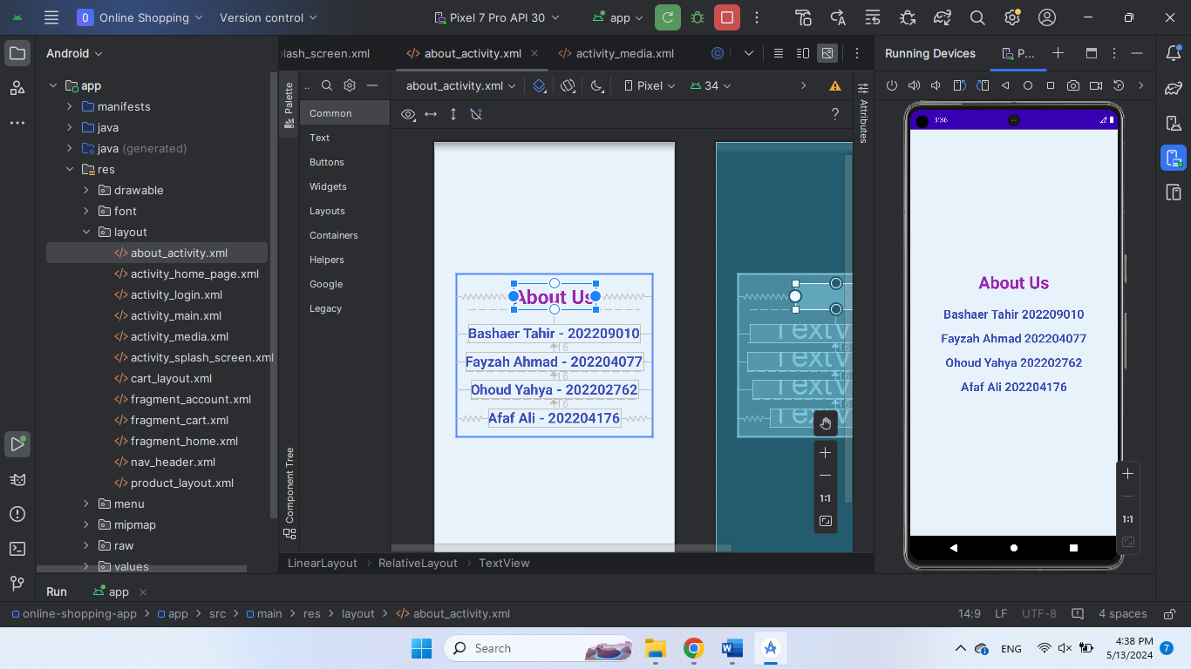

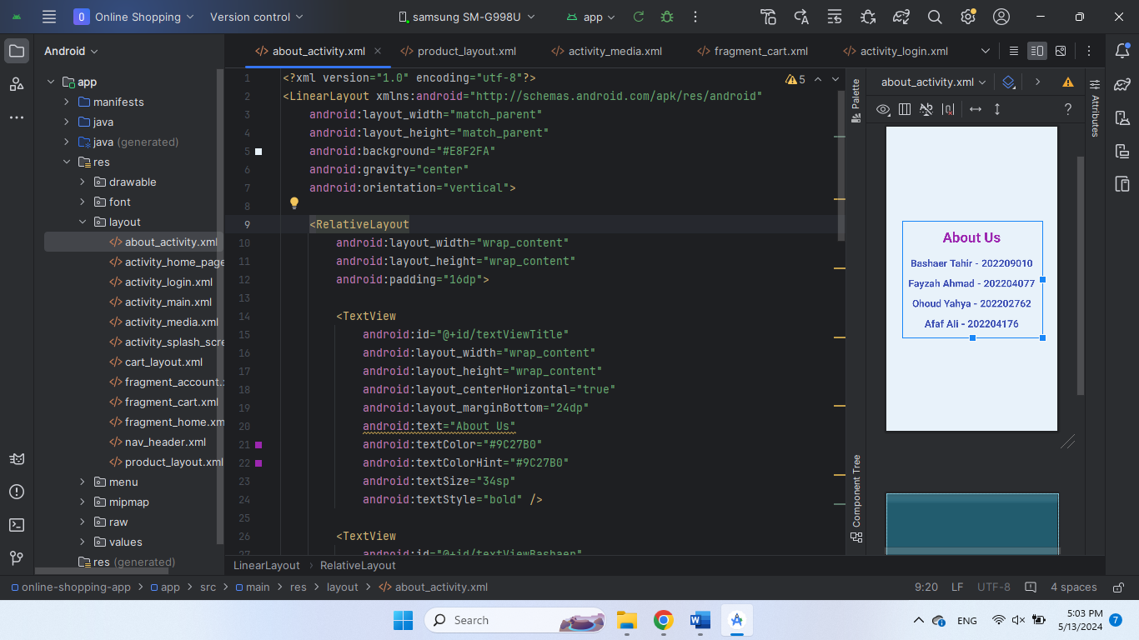

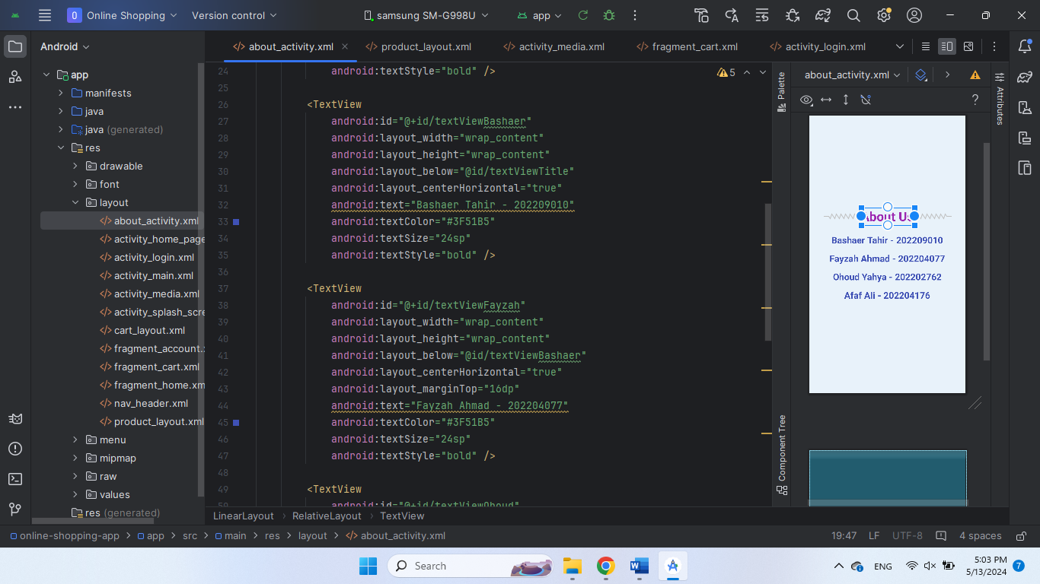

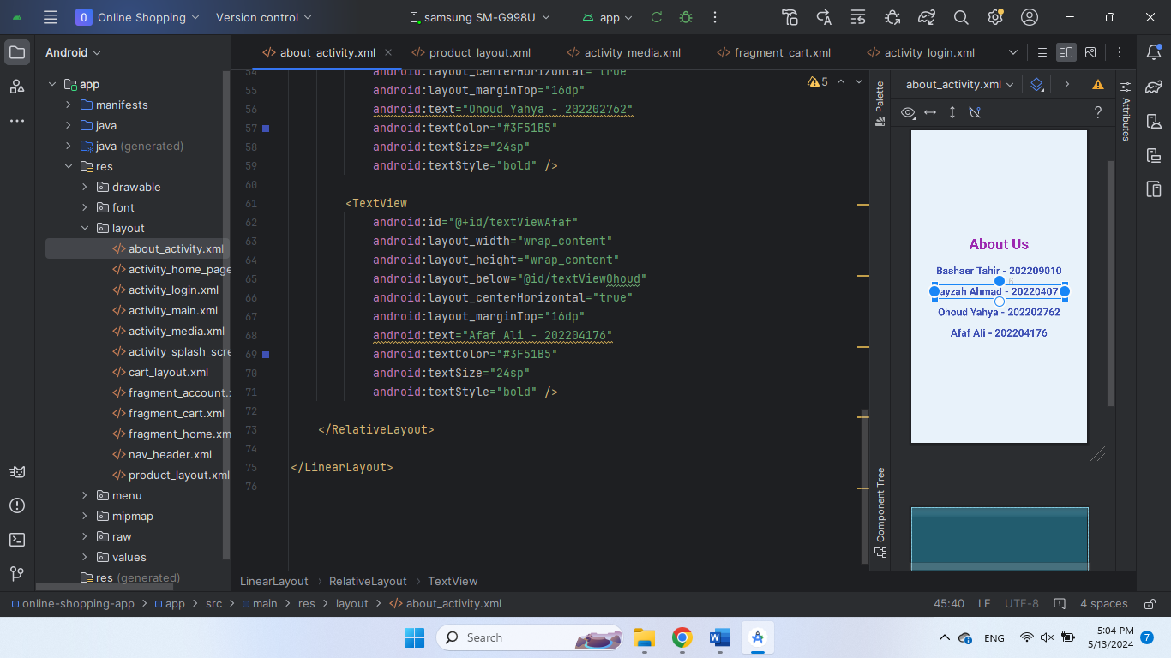

**Media page**

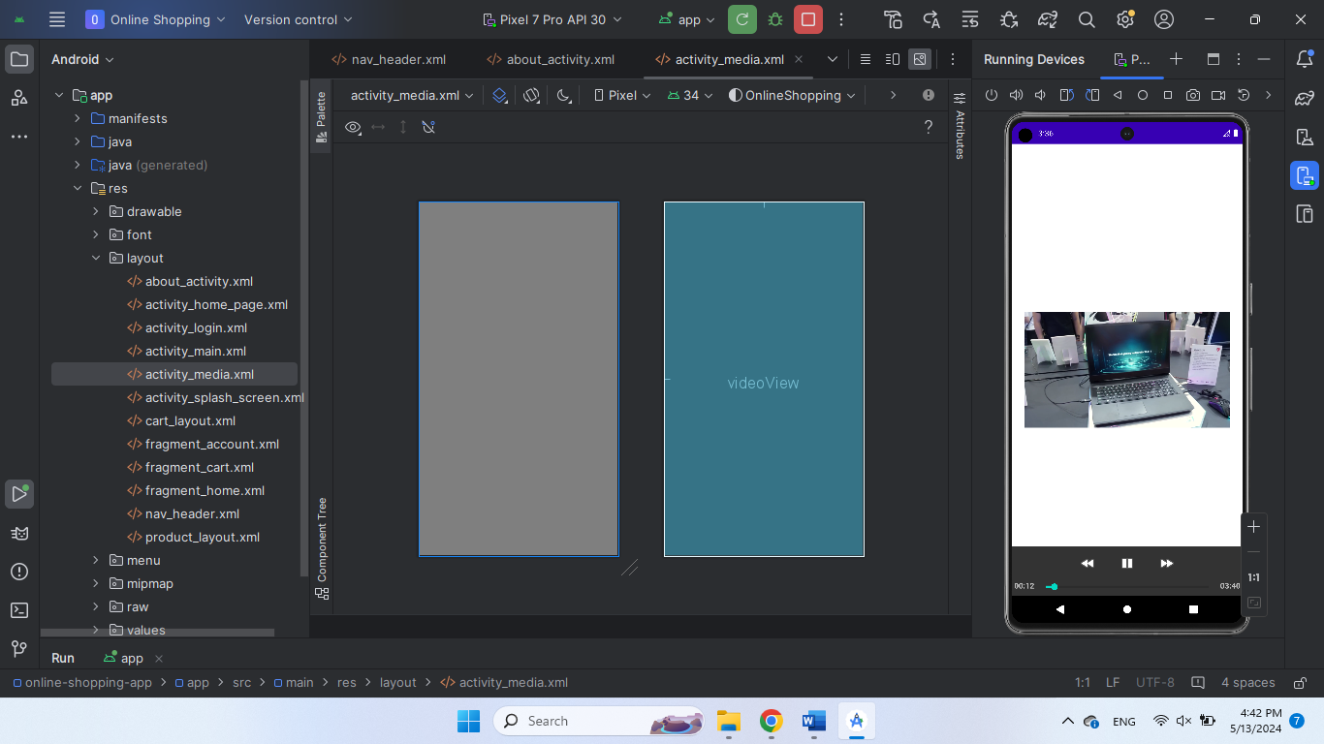

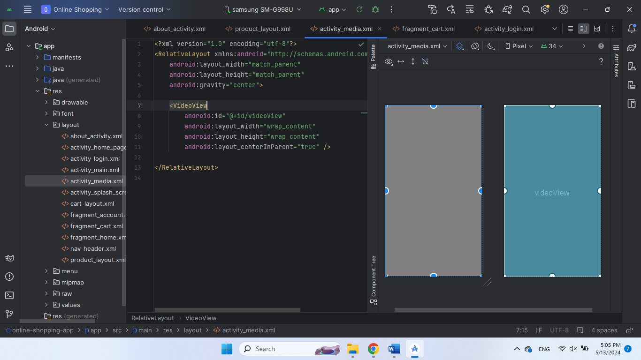

**Account page:**

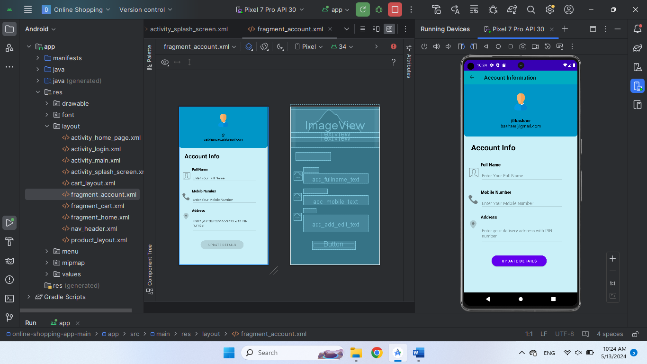

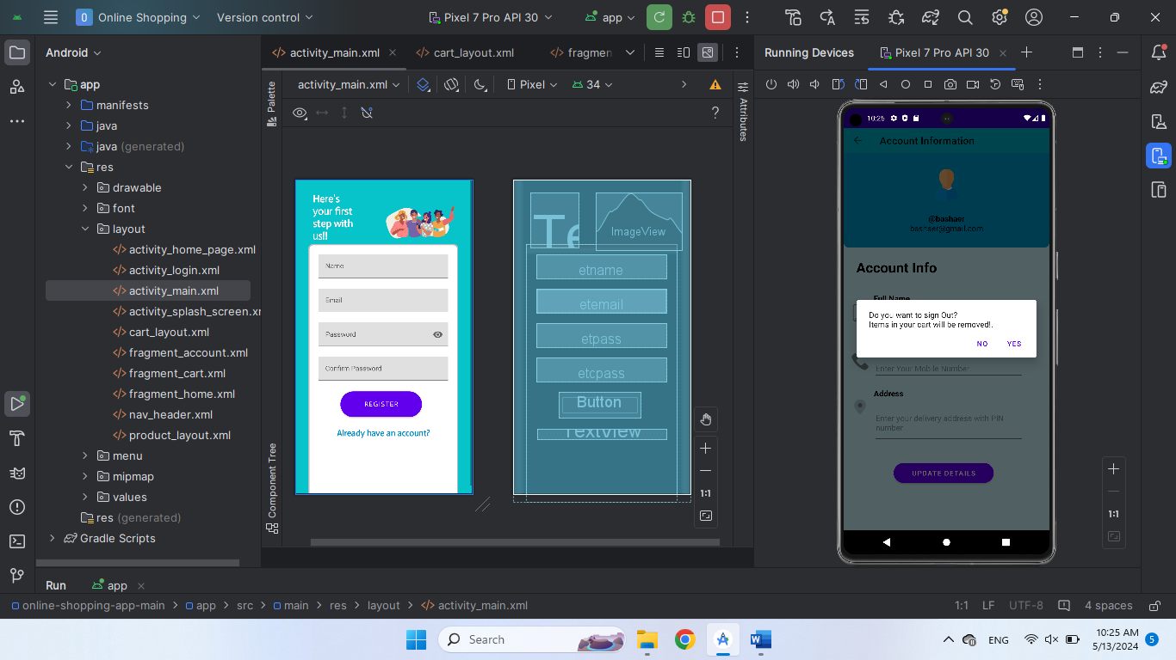

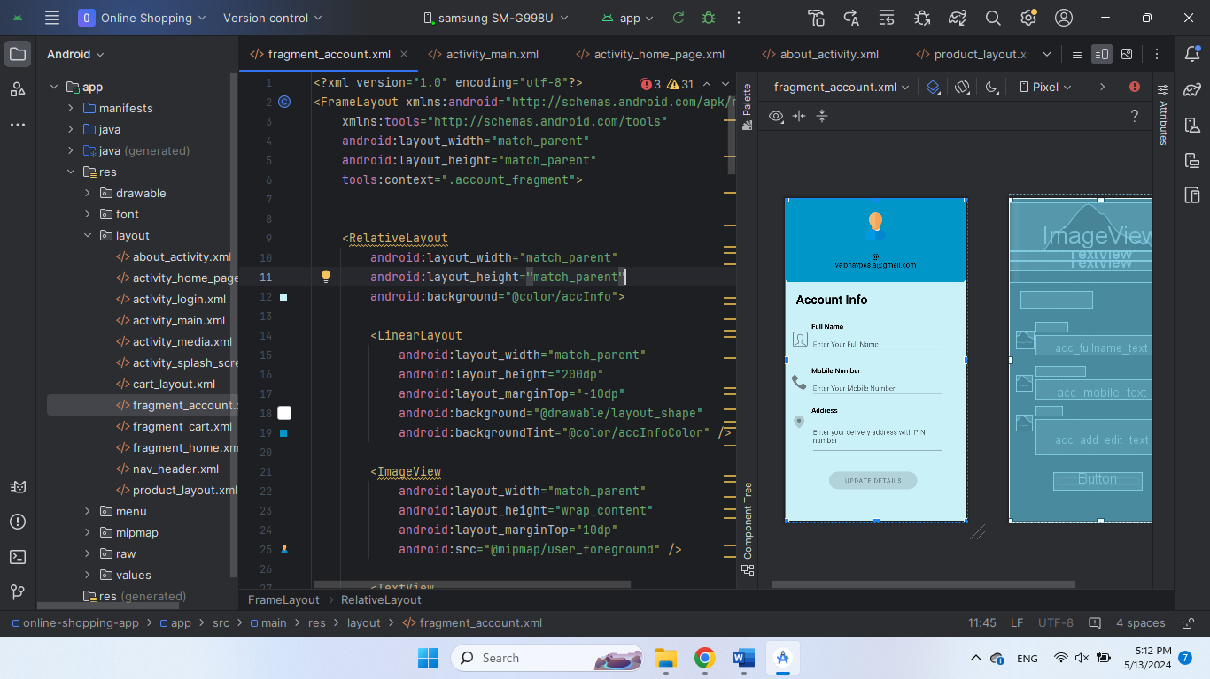

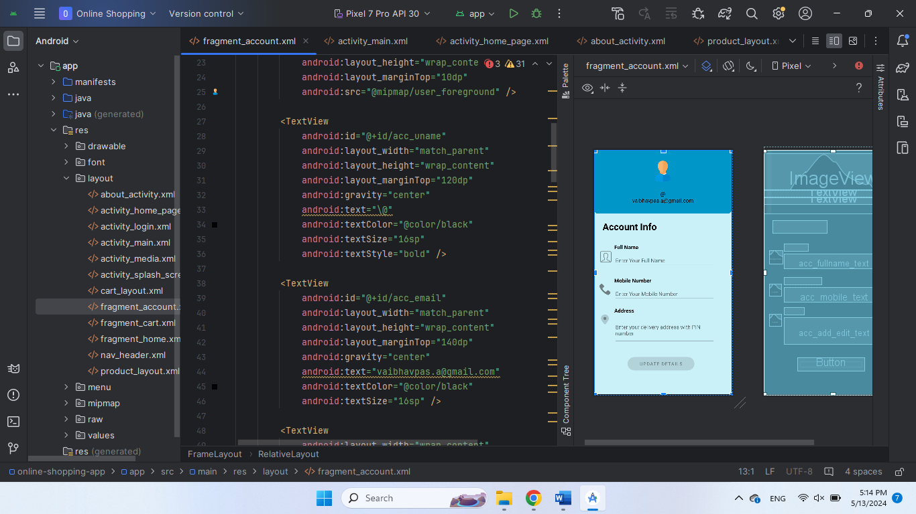

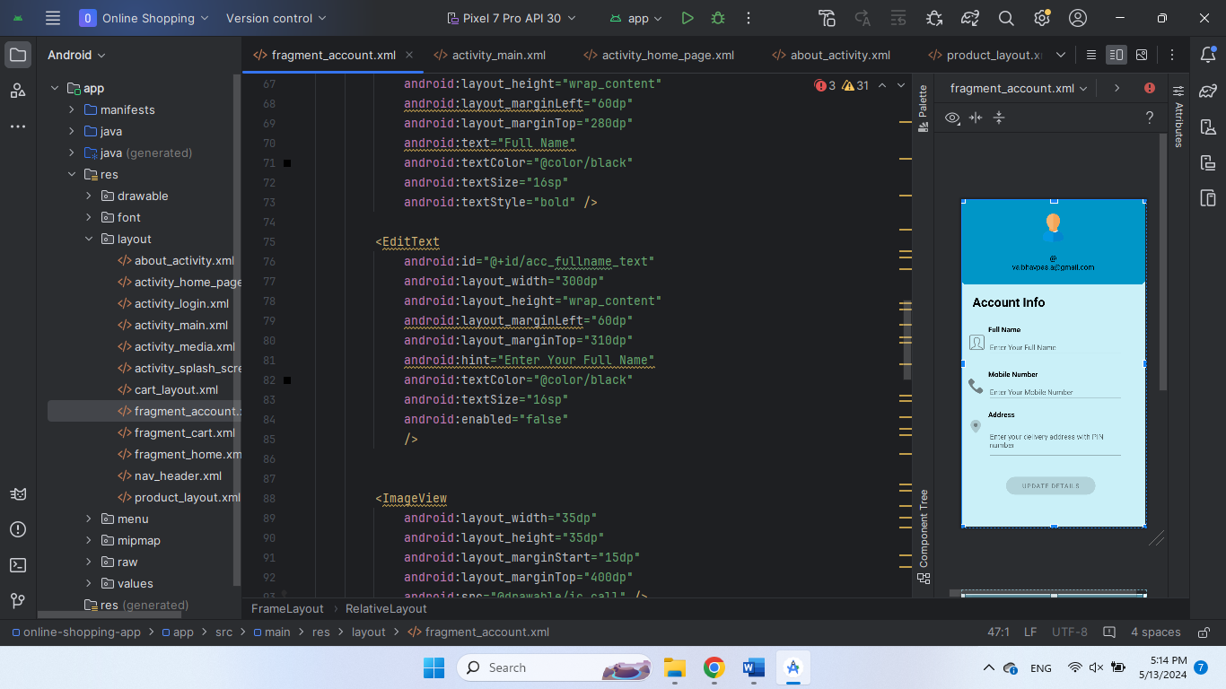

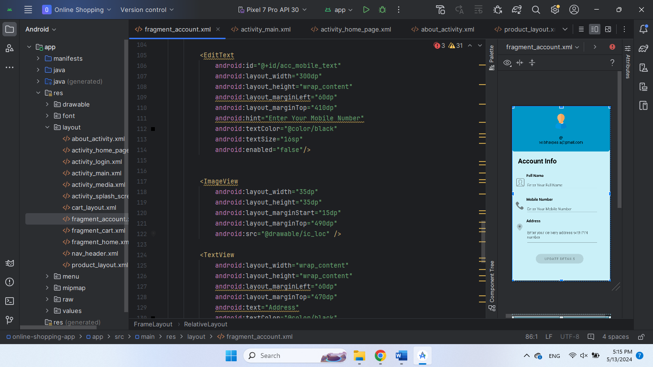

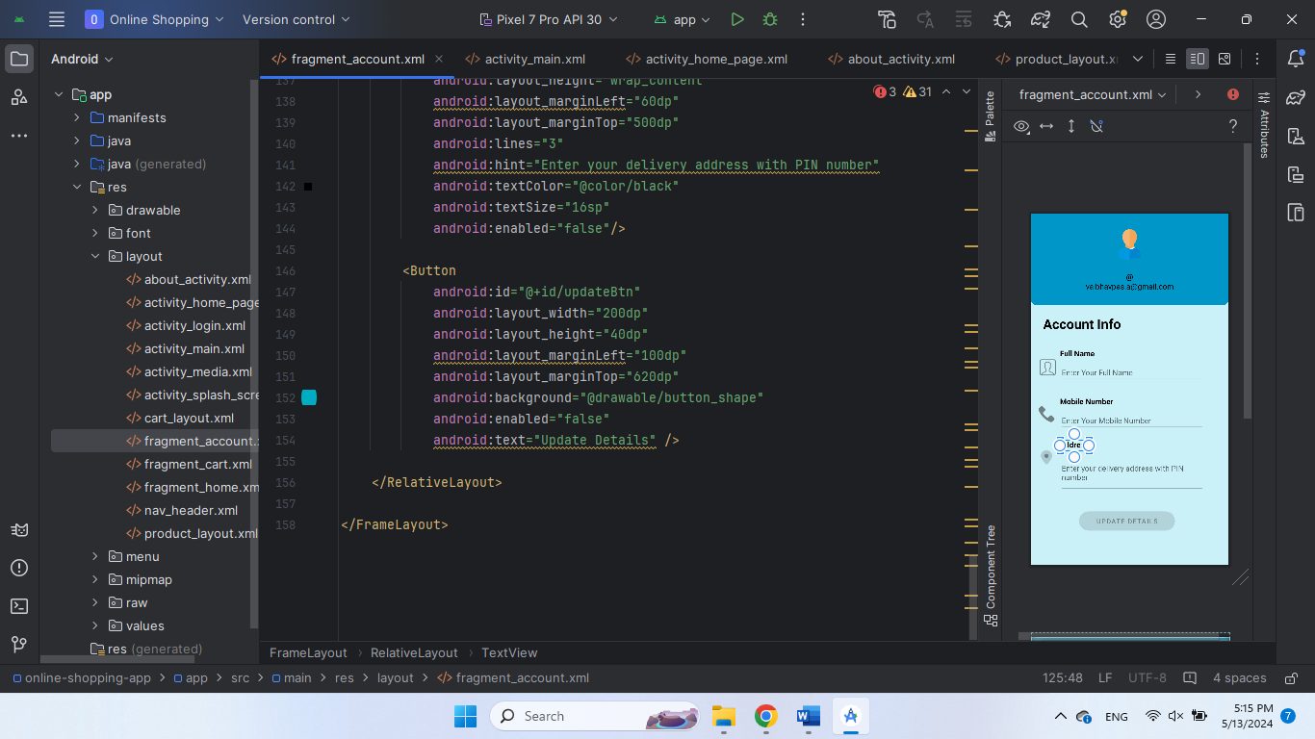

**Java:**

**Login:**

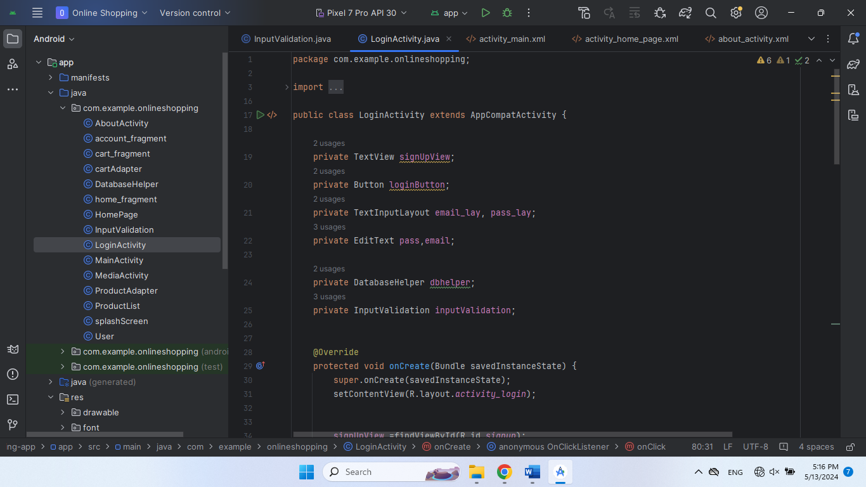

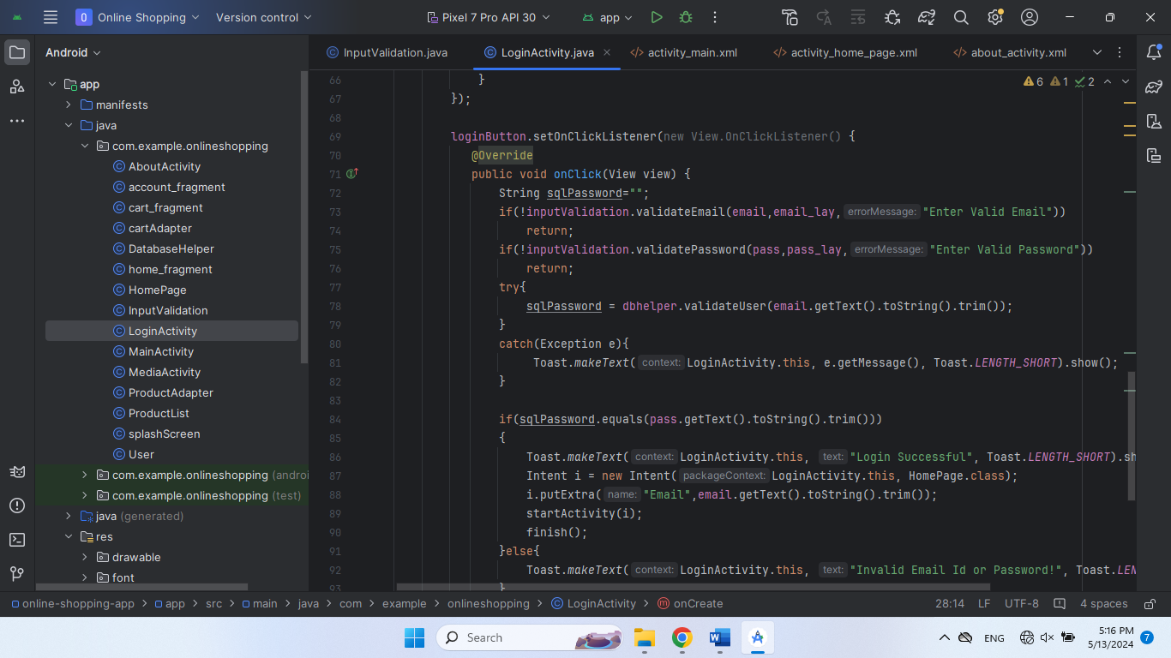

**MainActivity**

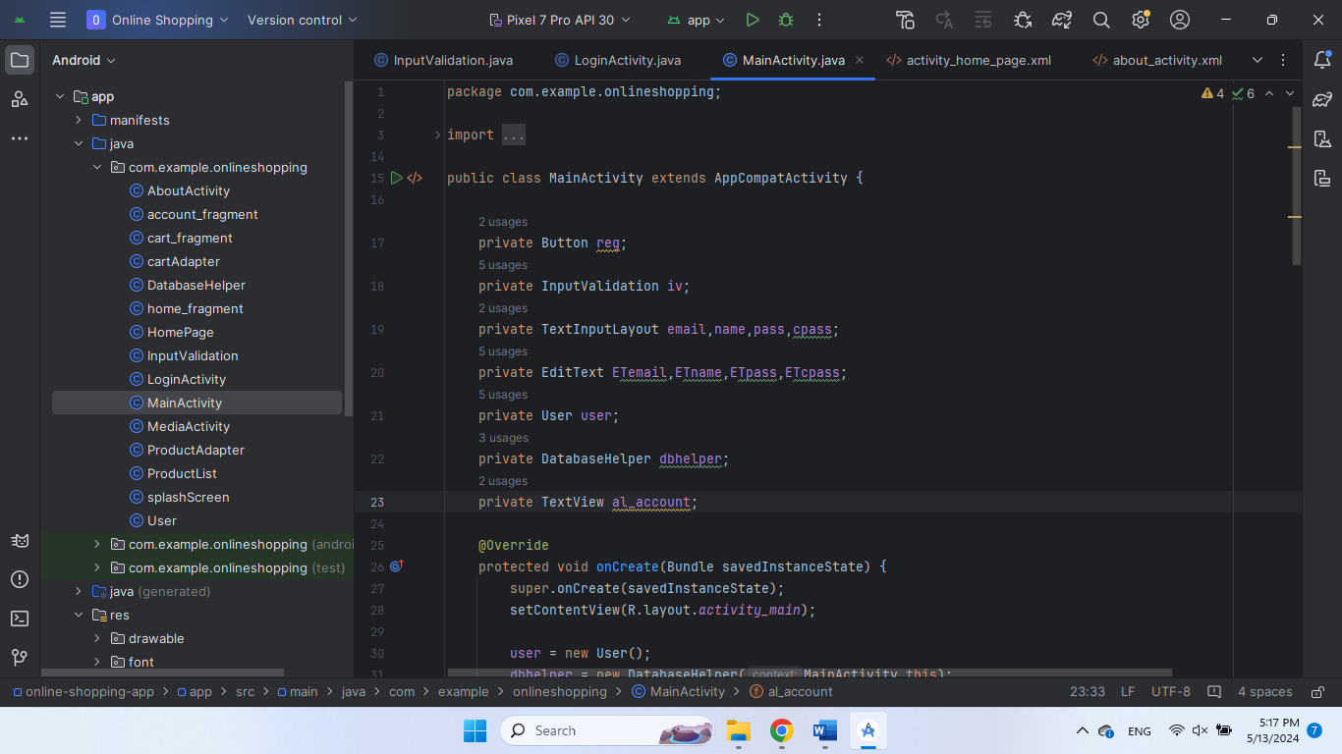

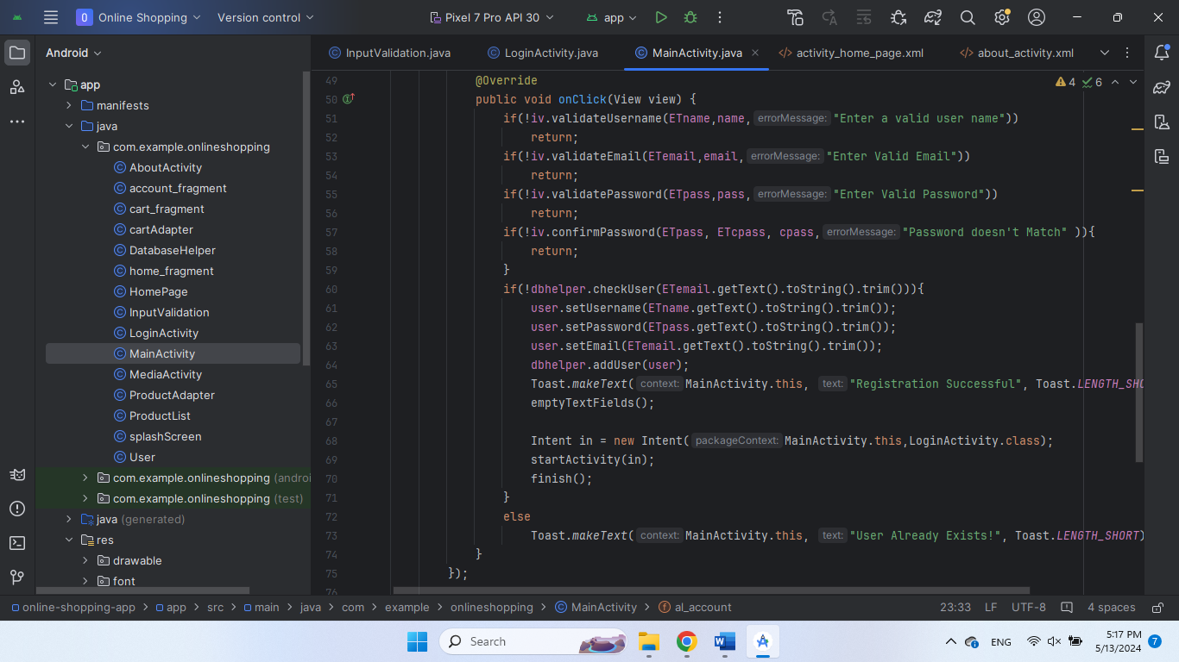

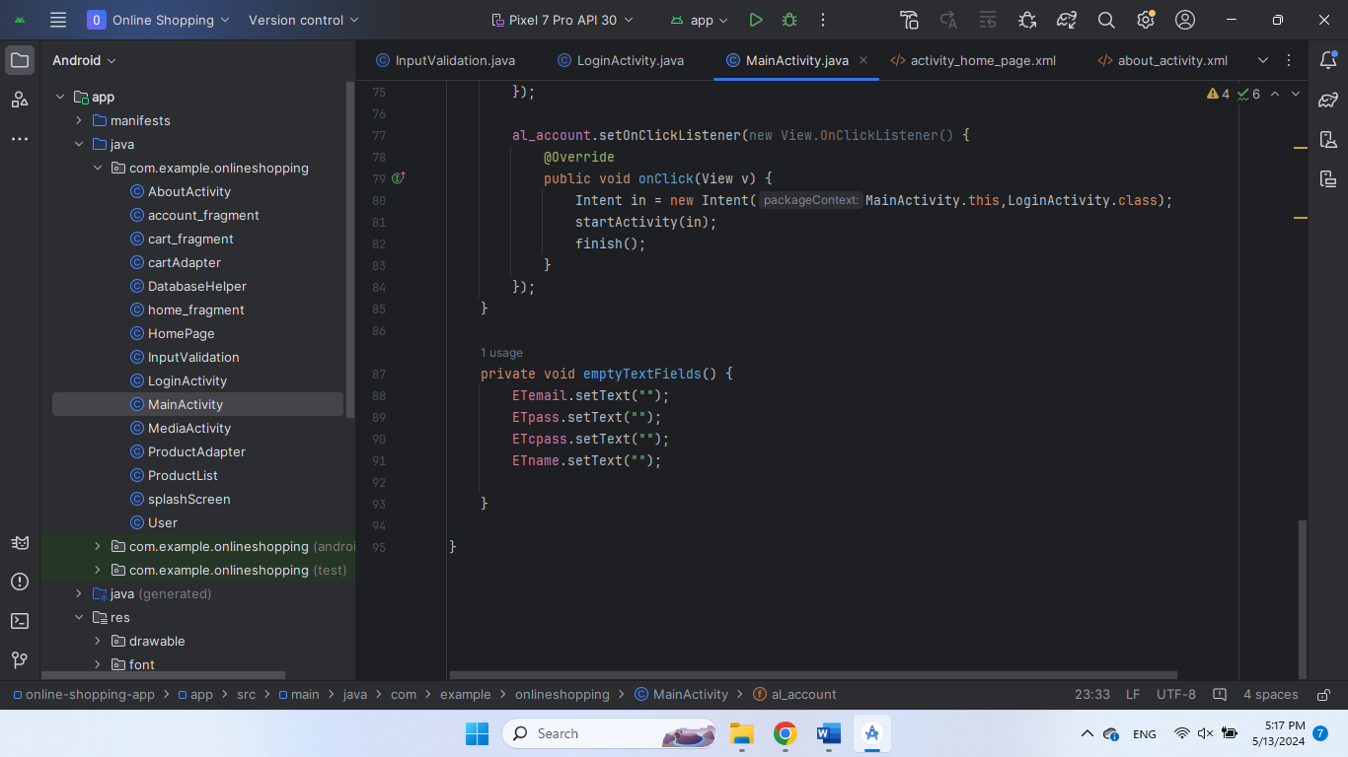

**MediaActivity**

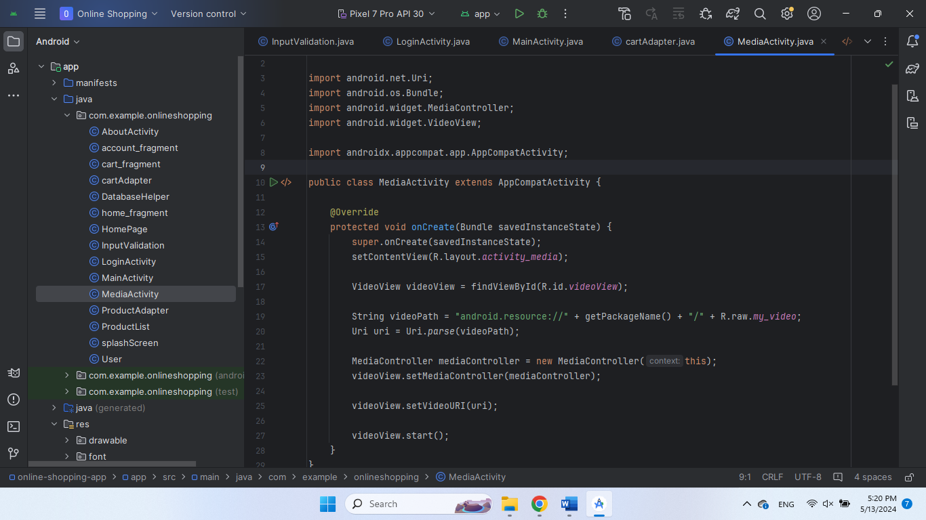

THE END!